Whack-A-Mole 1.0
A Linux Implementation of the Classic Electromechanical Arcade Game.

Threading Notes.

Overview:
The goal of this project was NOT to simply create a Whack-A-Mole game using a direct approach and appropriate design decisions. Rather, the goal was to create as many challenging thread interactions as possible, while doing so in a fun way. The result is this threaded, ncurses based game for Linux.
Please familiarize yourself with the game instructions by running the Whack-A-Mole program and pressing “I”. The instructions will help explain some of the game-related terms used throughout this document.

Thread Structure:
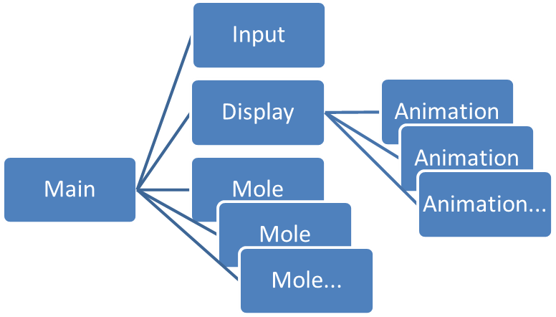
Thread Descriptions:
Main Thread
The main thread performs the following:
- Program initialization.
- Saves the terminal state, and sets the options for ncurses.
- Displays game instructions to the user.
- Creates the input and display threads, waiting for each to signal that it has started.
- Creates and monitors mole threads.
  - One thread per mole.
  - Up to three (configurable with #define) mole threads run concurrently.
- Joins completed mole threads.
- Cancels and joins input and display threads.
- Displays score sheet.
- Performs cleanup and restores terminal settings.

Input Thread - Handles terminal keyboard and communicates user input to the other threads.
Functions of the input thread are as follows:
- Reads the keyboard input from stdin, ignoring keys which are not associated with any mole hole.
- If the hole corresponding to a key press has a mole in the “UP” state:
  - Cancels the animation thread for that mole.
  - Signals mole thread, allowing it to awaken from waiting for input.
- If the hole has a mole in the “HIDING” state, or has no mole assigned at all:
  - Signals ALL mole threads that are in the “HIDING” or “UP” state that they should enter the “SCARED” state.
  - Creates an entry in the scores buffer as either a “BAD AIM”, or “TOO SOON” event.
- The input thread also contains support for a rudimentary self-test capability through use of the “AUTOPLAY” preprocessor definition.

Display Thread - Coordinates all updates to the display.
The display thread monitors the states of each mole thread, along with changes to the score sheet entries. Based on these, it does the following:
- Updates on-screen score and count of moles remaining.
- Handles the “BAD AIM” (giant “X”) display.
- Creates, monitors and joins animation threads.

Animation Threads - Each animation sequence of each mole is created as a separate thread. These animation threads step through each frame of the animation.
Animations may run to completion and allow the mole to continue to the next state, or they may be cancelled early due to player action.
Animation Types include:
- Hiding Mole - Just the ears bob up and down randomly in the hole.
- Popup - The mole quickly ascends from the bottom of the hole and rises to the top. It then slowly descends until it is whacked by the player or vanishes completely.
- Whacked - Mole was successfully whacked by the player.
- Escaped - Mole got away.
- Scared - Mole was scared off by the player hitting a wrong hole, or hitting a mole too soon (while it was still hiding).
The animation threads communicate frame progress information to the mole threads and the input thread to provide synchronization and for scoring.
Multiple animation threads may be running concurrently within the program, but each mole thread must wait for its current animation thread to terminate before creating another.

Mole Threads - Each mole thread implements a state machine controlling the actions of a particular mole within the game.
Mole States:
- Available - Indicates an unused spot where a mole thread can be created.
- Assigned - A mole thread has been created by the main thread, but has not fully started yet.
- Hiding - The mole thread has started, the mole has chosen a hole, but is not yet whackable.
- Up - This mole has popped up and can now be whacked by the player.
- Whacked - The player successfully whacked the mole by pressing the proper key before the mole escaped.
- Expired - The player failed to whack the mole in time, and it has now escaped.
- Scared - The player hit the key for a hole which had no mole assigned, or hit the key for a mole that was still hiding. Either case will cause ALL moles that are either “Hiding” or “Up” to be scared off, and no longer eligible to be whacked.
- Terminating - Mole has completed its interaction with the player, and is in the process of performing cleanup.
- Complete - Mole thread has terminated and may now be joined by the main thread.
Multiple concurrent mole threads can be running, limited by the value of the CONCURRENTMOLES preprocessor definition.
The mole threads also create score sheet entries based on the player interactions with the moles.

Thread Communications and Synchronization:
Global Data
MoleCommRecord structure - The Mole Communications Buffer.
Contains all information about the status of a mole while it is active.
Keeps all threads coordinated.
One MoleCommRecord in array for each concurrent mole thread. (Size set by CONCURRENTMOLES preprocessor definition)

ScoreSheetRecord structure - Detail of events throughout the game.
Contains an entry for each:
- Whacked mole
- Escaped mole
- Scared mole
- Player hitting wrong hole (BAD AIM)
- Player hitting hiding mole (TOO SOON)
Dynamically allocated/reallocated as each event occurs.
Maintains data for score sheet display, and is used by display thread to track “BAD AIM” events.

Animation Sync Points / Sync Count - Used by animation thread to communicate progress through the individual frames.
Sync count > 0 indicates animation running.
Sync count == Sync points indicates animation finished.
When mole is whacked, contents of sync count for the “UP” animation will indicate the stage of the mole at the time. The bonus score is based on this.

Mutexes
The following mutexes are used throughout the program. They are always locked in the order they appear here, in order to prevent deadlocks.
- start_mtx
Used, along with a condition variable, by both the display thread and input thread to indicate they have started.

- hole_mtx
Array of mutexes (one per hole). Guarantees only one mole can claim a hole at any given time. Also used to coordinate the “BAD AIM” (giant “X”) display.

- molecomm_mtx
Locks the mole communications buffer (molecomm). Molecomm is the main method of communications between the mole threads and the display and input threads.

- random_mtx
The random() library call is not totally thread safe, so we lock it.

- score_mtx
The scores buffer is dynamically allocated, and realloc(…) is called each time a score record is added. This potentially moves the array in memory, so it must be locked any time it is accessed.

- ncurses_mtx
Ncurses is not thread safe. We make ncurses calls from the display thread, and from multiple concurrent animation threads. This mutex prevents conflicts.

Cancellation State
All threads which are subject to being cancelled set their cancel state to “disabled” before acquiring a mutex lock, and do not enable cancellability until after the lock is released.
If a thread were cancelled while holding a lock, it could never release that lock. The program would then deadlock as soon as another thread tried to lock that mutex.

Condition Waits / Signals
The program makes extensive use of condition waits, timed waits, and signals. All condition waits are governed by a while loop, to handle spurious wake-ups.

Thread Joins
All threads are joined when they terminate or are cancelled, in order to prevent zombie threads.

Misc. Notes:
Macro Functions
A handful of small utility functions are implemented as #defines. These include the most commonly used mutex locks/unlocks and setting the thread cancellation state.
Moving these to functions makes the code easier to read by moving the error checks out of immediate view, allowing the reader to concentrate more on the overall logic flow of the program.
Implementing these functions as macros means that any error messages displayed will reflect the line number of the error, and not the line number within a function.

